**DEVOPS LAB**

NAME- Shubhi Dixit

SAP ID- 500094571

BATCH- 05

**Linux Commands-2**

**Task 1:**

* Open the terminal and use the pwd command to display the current working directory.
* Note down the directory path shown in the terminal.

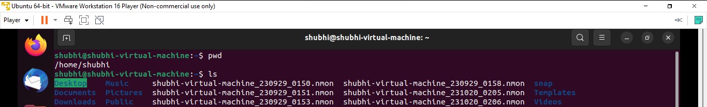

**Task 2:**

* Use the ls command to list the files and directories in the current working directory.
* Observe the output of the ls command and note the displayed items.

**Task 3:**

* Use the cd command to enter one of the listed directories obtained from Task 2.
* Use ls again to view the contents of the new directory.

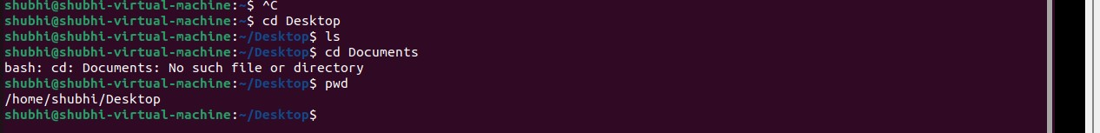

* Use pwd to confirm the updated current working directory path.



**Task 4:**

* Use cd with the appropriate command to move back to the parent directory.



* Verify the change by using pwd to display the current working directory path.

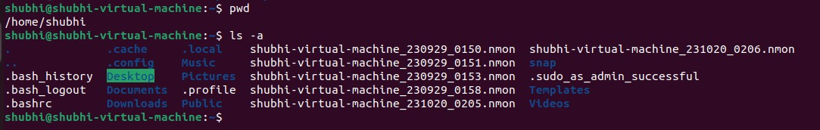

**Task 5:**

* Use ls -a command to display all files and directories, including hidden ones (starting with a dot).



* Observe hidden files and directories that weren’t displayed in the earlier ls

**Task 6:**

* Use cd followed by an absolute path to navigate to a specific directory in the file system.
* Confirm the change using pwd to display the current working directory.



**Task 7:**

* Create a file in a specific directory.



* Move files between directories.

**Task 8:**

* Create nested directory structures.

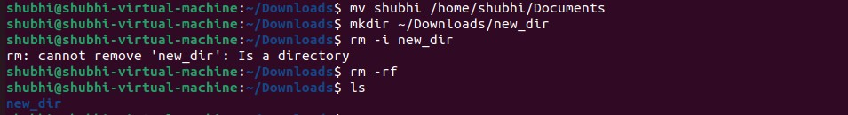

* Delete files/directories, ensuring confirmation before executing rm -rf commands.



**Tasks 9:**

1. **find Command:**
   * Find all files modified within the last 7 days in the /home/user/documents dir.
   * Search for files named "important_file.txt" in the entire file system.

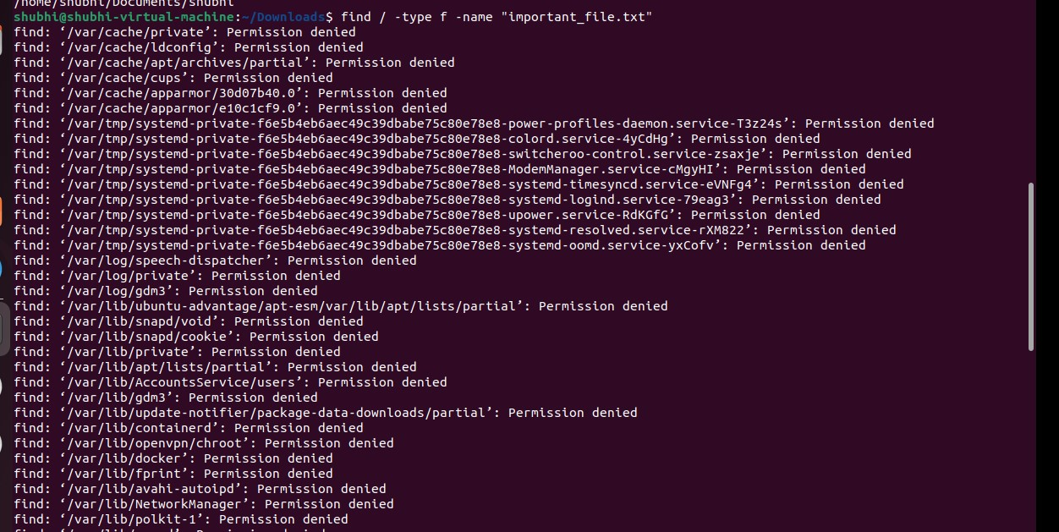

1. **grep Command:**
   * Create a sample text file containing multiple lines of text. Use grep to search for lines containing a specific keyword or pattern within the file.

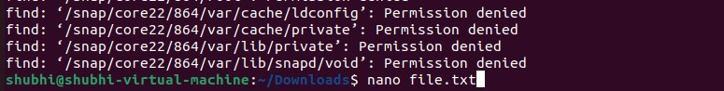

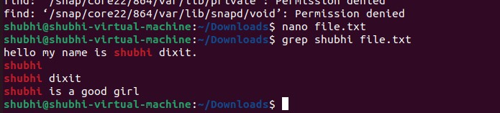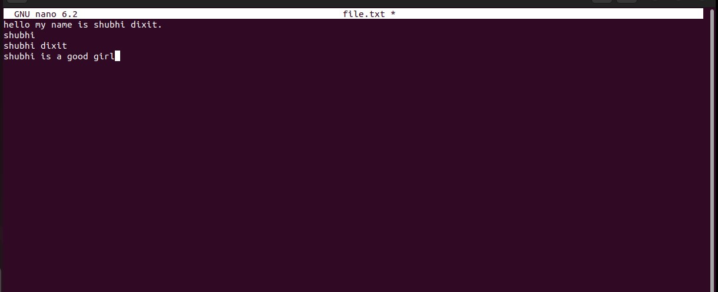

1. **tar Command:**

**Syntax:**

           tar [options] archive_name files/directories

* + Archive the contents of the /etc directory into a file named etc_archive.tar.
  + Compress the etc_archive.tar file using gzip to create etc_archive.tar.gz.

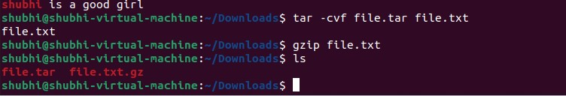

1. **gzip/gunzip Commands:**

**Syntax:**

gzip [options] file

* + Compress a sample text file using gzip and verify the compressed file's size.



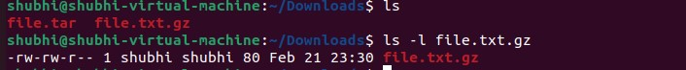

* + Decompress the compressed file using gunzip and ensure the content integrity is maintained.

